|  |  |  |
| --- | --- | --- |
| Picture background |  | Picture backgroundSaint Petersburg English Language Teachers’ Association |

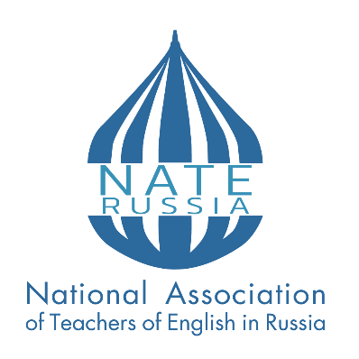

## NATIONAL ASSOCIATION OF TEACHERS OF ENGLISH IN RUSSIA (NATE-Russia)

# SAINT-PETERSBURG ENGLISH LANGUAGE TEACHERS ASSOCIATION (SPELTA)

# PUSHKIN LENINGRAD STATE UNIVERSITY

## XXХ NATE-Russia Conference

## *MEETING CHALLENGES AND USING OPPORTUNITIES*

**Dear colleagues,**

The National Association of Teachers of English (NATE-Russia) is pleased to invite you to the XXX international conference “Meeting Challenges and Using Opportunities”.

**Venue:** Pushkin Leningrad State University

**Address:** 10A Petersburgskoye shosse (Petersburg highway), Saint Petersburg (town of Pushkin)

**Dates:** April 10-13, 2025

**Conference Format:** mixed (in-person and online)

**Working languages:** English, Russian

**Conference content areas:**

* Modern problems of teaching foreign languages in the digital era
* Professional training of foreign language teachers: training, retraining and support
* Challenges of teaching interpreters and translators in the digital age
* Current issues of language testing
* Challenges of inclusive education
* Multilingual and multicultural environment of a modern university
* Professionally oriented English Language Teaching (ESP)
* Internationalization of the continual education
* English language studies

**The conference will include:** plenary and SIG presentations, workshops, panel and round table discussions, cultural program.

**Presentation time limit:**

* Plenary presentation – 20 min.
* SIG presentation – 10 min.
* Workshops – 40 min.
* Panel and round table discussions – 40 min.

**Registration and fee payment deadlines:**

* Speakers Registration – March 1, 2025
* Attendees Registration – April 1, 2025
* Notice of acceptance for speakers – March 10, 2025
* Participation fee payment

- for speakers with presentations accepted and included to the Program of the Conference –March 15, 2025[1]

- for attendees – April 5, 2025

Follow the link to register at the Conference: <https://forms.gle/1tthg3QnkYRpr2hv6>

**Contacts:**

[speltareg@gmail.com](mailto:speltareg@gmail.com) – Tatiana Ivanova

Maria Poddubnaya

[svetlana_chspu@mail.ru](mailto:svetlana_chspu@mail.ru) – Svetlana Sannikova

1. Presentations with no fee paid before the deadline are not to be included to the final version of the Program.